Ionic Framework

**Ionic** is open source framework used for developing mobile applications. It provides tools and services for building Mobile UI with native look and feel.

Ionic is using AngularJS MVC architecture for building rich single page applications optimized for mobile devices.

Ionic Framework Advantages

* Ionic is used for Hybrid App Development. This means that you can package your applications for IOS, Android, Windows Phone and Firefox OS, which can save you a lot of working time.
* Starting your app is very easy since Ionic provides useful pre-generated app setup with simple layouts.
* The apps are built in a very clean and modular way, so it is very maintainable and easy to update.

## Installing Cordova and Ionic

npm install -g cordova ionic

While creating apps in Ionic, you can choose from the following three options to start with

* Tabs App
* Blank App
* Side menu app

ionic start myApp tabs

Ionic **Start** command will create a folder named **myApp** and setup Ionic files and folders.

Let us now add the Cordova project for the Android Platform and install the basic Cordova plugins as well. The following code allows us to run the app on the Android emulator or a device.

ionic platform add android

The next step is to build the app. If you have building errors after running the following command, you probably did not install the Android SDK and its dependencies.

ionic build android

The last step of the installation process is to run your app, which will start the mobile device, if connected, or the default emulator

ionic run android

ionic start myApp blank- this command creates a blank screen

ionic start myApp sidemenu - this command creates a side menu

ionic serve - The above command will open your app in the web browser

## Ionic Color Classes

Ionic framework gives us a set of **nine predefined color classes**

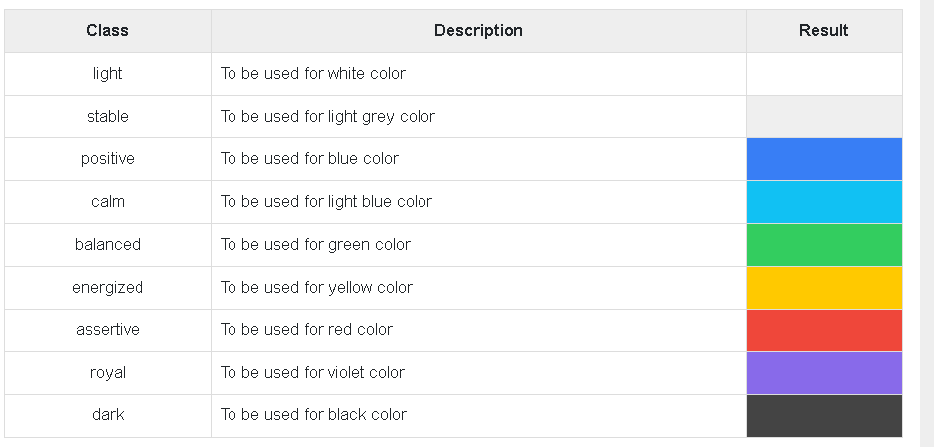

Header Colours

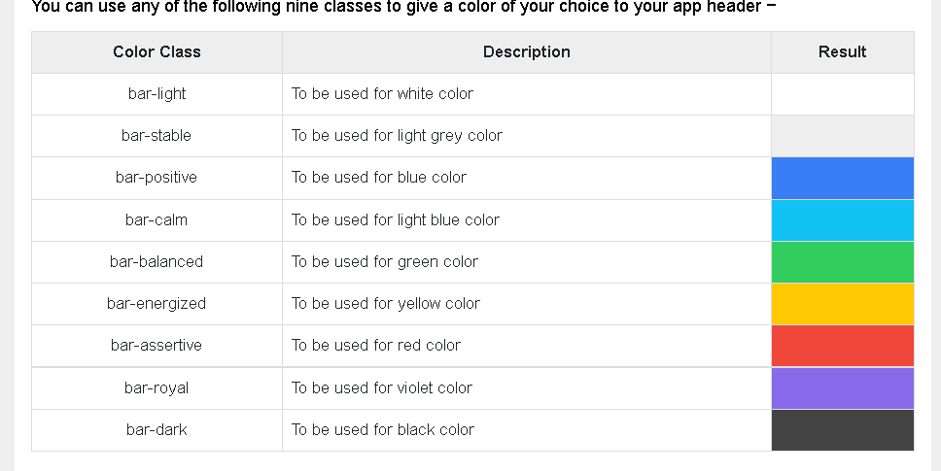

Button Colours

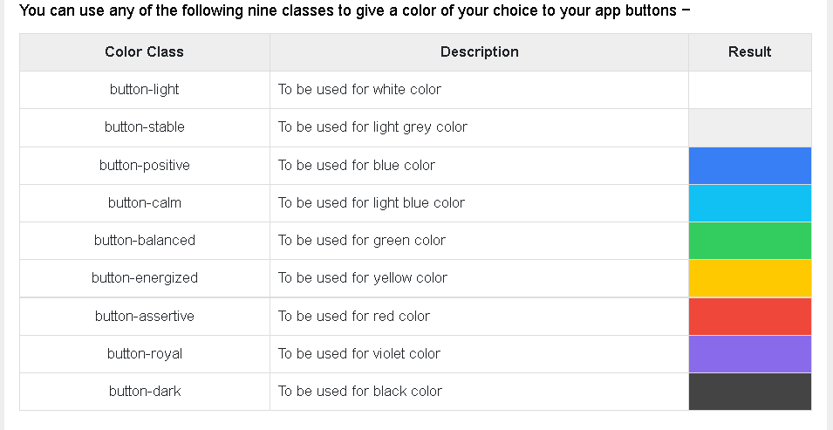

## Generating New Features[​](https://ionicframework.com/docs/developing/scaffolding#generating-new-features)

By running ionic generate in the command line, a selection prompt is displayed which lists the available features that can be generated.

$ ionic generate

? What would you like to generate?

❯ page

component

service

module

class

directive

guard

After running generate command it asks for name of the page

? What would you like to generate? page

? Name/path of page: portfolio

**Keyboard**

One of the most important thing for developers is keyboard, how and what options do we need while using the keyboard.

## inputmode

The inputmode attribute allows developers to specify what type of data might be entered into an input. This will prompt the browser to show a keyboard that includes buttons relevant to what the user may enter. For example, inputmode="email" will display a keyboard with the @ key as well as other optimizations for entering emails.

<ion-item>

<ion-label>Username or Email</ion-label>

<ion-input inputmode="email"></ion-input>

</ion-item>

<ion-item>

<ion-label>Enter a number</ion-label>

<ion-textarea inputmode="numeric"></ion-textarea>

</ion-item>

Inputs that require a certain data type should use the type attribute instead. For example, inputs that require an email should use type="email" rather than specifying an inputmode. This is because the data that will be entered is always going to be in the form of an email. On the other hand, if the input accepts an email or a username, using inputmode=”email” is appropriate because the data being entered is not always going to be an email address.

**List of accepted values for inputmode**

None,text,tel,decimal,numeric,search,email,url

## Enterkeyhint

## The enterkeyhint attribute allows developers to specify what type of action label or icon should be shown for the "Enter" key. Using enterkeyhint lets the user know what will happen when they tap the “Enter” key. The value that should be specified here depends on the context of what the user is doing. For example, if the user is typing into a searchbox, developers should ensure that the input has enterkeyhint="search".

## 

## Dark Mode

By default the keyboard theme is determined by the OS. For example, if dark mode is enabled on iOS, the keyboard in your app will appear with a dark theme even if your application does not have a dark theme in its CSS.

When running an app in a mobile web browser or as a PWA there is no way to force the keyboard to appear with a certain theme.